EX:1
DATE:

Aim:
To develop a basic Android application using Kotlin in Android Studio that changes the background color, font style, and font size when a button is clicked.

Procedure:
- Open Android Studio.
- Click on New Project.
- Select Empty Activity and click Next.
- Enter the Application Name.
- Select Java as the programming language.
- Click Finish.
- Open activity_main.xml and design the layout with:
  - One TextView
  - One Button
- Open MainActivity.java.
- Write Java code inside the button’s setOnClickListener() to:
  - Change background color
  - Change font style
  - Change font size
- Run the application using an emulator or Android device.
PROGRAM:
activity_main.xml:

<?xml version="1.0" encoding="utf-8"?>
<LinearLayout
xmlns:android="http://schemas.android.com/apk/res/android"
android:id="@+id/mainLayout"
android:layout_width="match_parent"
android:layout_height="match_parent"
android:orientation="vertical"
android:gravity="center"
android:background="#FFFFFF">

<TextView
android:id="@+id/textView"
android:layout_width="wrap_content"
android:layout_height="wrap_content"
android:text="Hello Android!"
android:textSize="18sp"
android:layout_marginBottom="20dp"/>

<Button
android:id="@+id/btnChange"
android:layout_width="wrap_content"
android:layout_height="wrap_content"
android:text="Change Style"/>
</LinearLayout>

MainActivity.java:

package com.example.example;

import android.graphics.Color;
import android.graphics.Typeface;
import android.os.Bundle;
import android.widget.Button;
import android.widget.LinearLayout;
import android.widget.TextView;
import androidx.appcompat.app.AppCompatActivity;

public class MainActivity extends AppCompatActivity {

boolean changed = false;

@Override
protected void onCreate(Bundle savedInstanceState) {
super.onCreate(savedInstanceState);
setContentView(R.layout.activity_main);

TextView textView = findViewById(R.id.textView);
Button button = findViewById(R.id.btnChange);
LinearLayout layout = findViewById(R.id.mainLayout);

button.setOnClickListener(v -> {

if (!changed) {
layout.setBackgroundColor(Color.LTGRAY);

textView.setTypeface(null, Typeface.BOLD_ITALIC);

textView.setTextSize(24);

changed = true;

} else {

layout.setBackgroundColor(Color.WHITE);
textView.setTypeface(null, Typeface.NORMAL);
textView.setTextSize(18);

changed = false;
}
});
}
}

Output:

Before clicking:

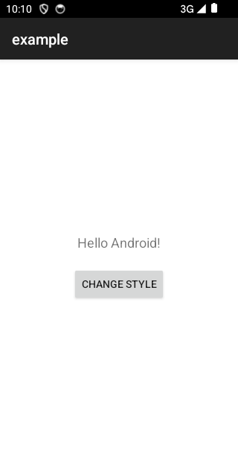

After clicking:

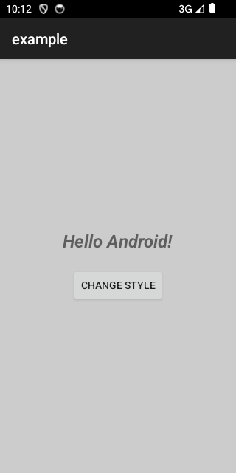

Result:

Hence, The application was successfully executed and the button click event worked correctly. The background color, font style, and font size changed dynamically when the button was pressed.

EX:2
DATE:

Aim

To develop an Android calculator application using Java and event listeners to perform basic arithmetic operations such as:

Addition

Subtraction

Multiplication

Division

Procedure

Create a new Android project in Android Studio.

Design the user interface using XML (EditText, Buttons, and TextView).

Add buttons for numbers (0–9) and arithmetic operators (+, –, ×, ÷).

Use event listeners (setOnClickListener) to handle button clicks.

Write Java code to perform arithmetic operations.

Display the result in a TextView.

Run the application on an emulator or Android device.

PROGRAM

1. activity_main.xml

<?xml version="1.0" encoding="utf-8"?>

<LinearLayout

xmlns:android="http://schemas.android.com/apk/res/android"

android:layout_width="match_parent"

android:layout_height="match_parent"

android:orientation="vertical"

android:padding="24dp"

android:gravity="center_vertical"

android:background="#F5F5F5">

<TextView

android:layout_width="wrap_content"

android:layout_height="wrap_content"

android:text="Simple Calculator"

android:textSize="24sp"

android:textStyle="bold"

android:layout_gravity="center"

android:layout_marginBottom="32dp"

android:textColor="#333333"/>

<EditText

android:id="@+id/etNumber1"

android:layout_width="match_parent"

android:layout_height="wrap_content"

android:hint="First Number"

android:inputType="numberDecimal"

android:padding="12dp"

android:background="@android:drawable/editbox_background"/>

<EditText

android:id="@+id/etNumber2"

android:layout_width="match_parent"

android:layout_height="wrap_content"

android:hint="Second Number"

android:inputType="numberDecimal"

android:layout_marginTop="12dp"

android:padding="12dp"

android:background="@android:drawable/editbox_background"/>

<LinearLayout

android:layout_width="match_parent"

android:layout_height="wrap_content"

android:orientation="horizontal"

android:layout_marginTop="24dp">

<Button

android:id="@+id/btnAdd"

android:layout_width="0dp"

android:layout_height="wrap_content"

android:layout_weight="1"

android:text="Add (+)"

android:layout_marginEnd="4dp"/>

<Button

android:id="@+id/btnSub"

android:layout_width="0dp"

android:layout_height="wrap_content"

android:layout_weight="1"

android:text="Sub (-)"

android:layout_marginStart="4dp"/>

</LinearLayout>

<LinearLayout

android:layout_width="match_parent"

android:layout_height="wrap_content"

android:orientation="horizontal"

android:layout_marginTop="8dp">

<Button

android:id="@+id/btnMul"

android:layout_width="0dp"

android:layout_height="wrap_content"

android:layout_weight="1"

android:text="Mul (×)"

android:layout_marginEnd="4dp"/>

<Button

android:id="@+id/btnDiv"

android:layout_width="0dp"

android:layout_height="wrap_content"

android:layout_weight="1"

android:text="Div (÷)"

android:layout_marginStart="4dp"/>

</LinearLayout>

<TextView

android:id="@+id/txtResult"

android:layout_width="match_parent"

android:layout_height="wrap_content"

android:text="Result: 0"

android:textSize="22sp"

android:textColor="#2E7D32"

android:textStyle="bold"

android:layout_marginTop="32dp"

android:gravity="center"

android:padding="16dp"

android:background="#E8F5E9"/>

</LinearLayout>

2. MainActivity.java

package com.example.calculatorapp;

import androidx.appcompat.app.AppCompatActivity;

import android.os.Bundle;

import android.widget.Button;

import android.widget.EditText;

import android.widget.TextView;

import android.widget.Toast;

public class MainActivity extends AppCompatActivity {

// Declare UI components

private EditText etNumber1, etNumber2;

private TextView txtResult;

@Override

protected void onCreate(Bundle savedInstanceState) {

super.onCreate(savedInstanceState);

setContentView(R.layout.activity_main);

// Initialize UI components

etNumber1 = findViewById(R.id.etNumber1);

etNumber2 = findViewById(R.id.etNumber2);

txtResult = findViewById(R.id.txtResult);

Button btnAdd = findViewById(R.id.btnAdd);

Button btnSub = findViewById(R.id.btnSub);

Button btnMul = findViewById(R.id.btnMul);

Button btnDiv = findViewById(R.id.btnDiv);

// Set Click Listeners using Lambdas (Supported in API 33)

btnAdd.setOnClickListener(v -> calculate('+'));

btnSub.setOnClickListener(v -> calculate('-'));

btnMul.setOnClickListener(v -> calculate('*'));

btnDiv.setOnClickListener(v -> calculate('/'));

}

private void calculate(char operator) {

String s1 = etNumber1.getText().toString();

String s2 = etNumber2.getText().toString();

// Check if inputs are empty

if (s1.isEmpty() || s2.isEmpty()) {

Toast.makeText(this, "Please enter both numbers", Toast.LENGTH_SHORT).show();

return;

}

double num1 = Double.parseDouble(s1);

double num2 = Double.parseDouble(s2);

double result = 0;

switch (operator) {

case '+': result = num1 + num2; break;

case '-': result = num1 - num2; break;

case '*': result = num1 * num2; break;

case '/':

if (num2 == 0) {

Toast.makeText(this, "Error: Division by zero", Toast.LENGTH_SHORT).show();

return;

}

result = num1 / num2;

break;

}

// Update the result view

txtResult.setText("Result: " + result);

}

}

Output
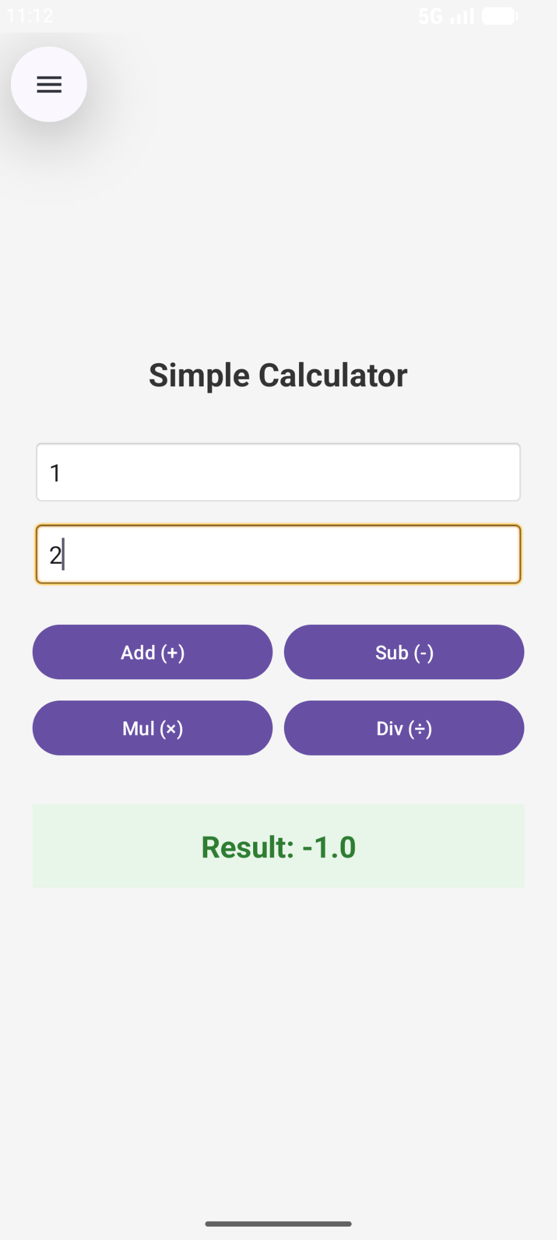
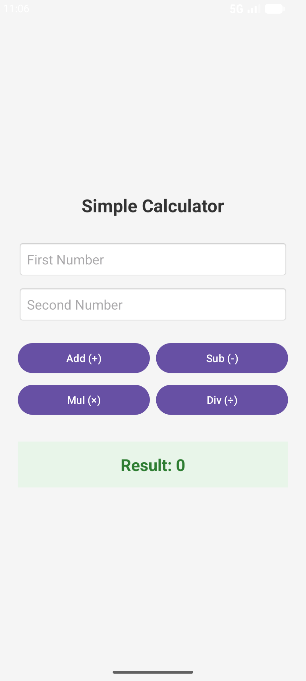

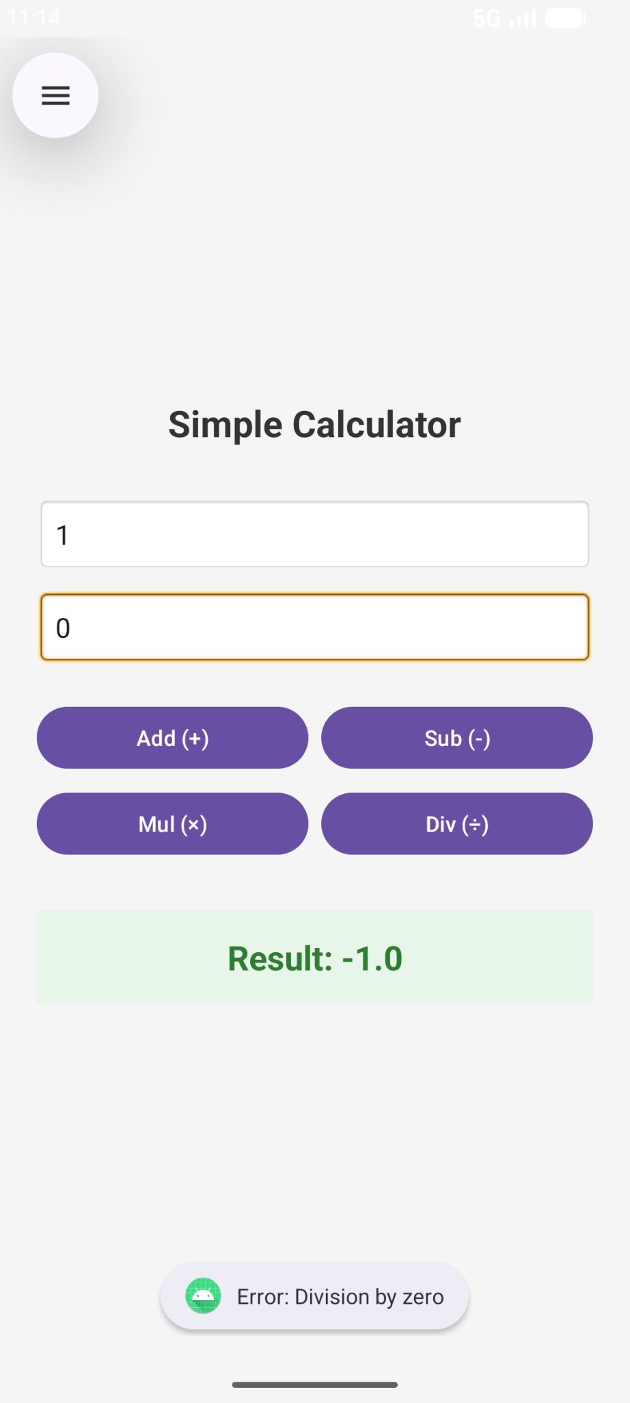

Result

Thus, an Android Calculator application was successfully developed using Java, XML layouts, and event listeners to perform basic arithmetic operations such as addition, subtraction, multiplication, and division.

EX: 3

DATE:

Aim

To develop an Android application to send emails and generate notifications when receiving mails or messages.

Procedure

Open Android Studio.

Click on New Project.

Select Empty Activity and click Next.

Enter the Application Name (e.g., EmailNotificationApp).

Select Java or Kotlin as the programming language.

Click Finish to create the project.

Design the user interface using XML or Jetpack Compose with:

EditText / TextField for Receiver Email

EditText / TextField for Subject

EditText / TextField for Message

Button to send email

Add required permissions in AndroidManifest.xml:

Internet permission

Notification permission (for Android 13+)

Configure email sending using SMTP protocol.

Implement background task (WorkManager or Service) to check incoming emails periodically.

Create a Notification Channel for displaying notifications.

Trigger notification when new email/message is detected.

Run the application using an emulator or Android device.

PROGRAM
package com.example.noname
import android.Manifest
import android.app.NotificationChannel
import android.app.NotificationManager
import android.content.Context
import android.content.pm.PackageManager
import android.os.Build
import android.os.Bundle
import androidx.activity.ComponentActivity
import androidx.activity.compose.setContent
import androidx.compose.foundation.layout.*
import androidx.compose.foundation.rememberScrollState
import androidx.compose.foundation.verticalScroll
import androidx.compose.material3.*
import androidx.compose.runtime.*
import androidx.compose.ui.Modifier
import androidx.compose.ui.text.input.TextFieldValue
import androidx.compose.ui.unit.dp
import androidx.core.app.ActivityCompat
import androidx.core.app.NotificationCompat
import androidx.core.content.ContextCompat
import androidx.work.*
import java.util.*
import java.util.concurrent.TimeUnit
import javax.mail.*
import javax.mail.internet.InternetAddress
import javax.mail.internet.MimeMessage
class MainActivity : ComponentActivity() {
override fun onCreate(savedInstanceState: Bundle?) {
super.onCreate(savedInstanceState)
requestNotificationPermission()
startEmailChecker()
setContent {
MaterialTheme {
MailUI()
}
}
}
private fun requestNotificationPermission() {
if (Build.VERSION.SDK_INT >= Build.VERSION_CODES.TIRAMISU) {
if (ContextCompat.checkSelfPermission(
this,
Manifest.permission.POST_NOTIFICATIONS
) != PackageManager.PERMISSION_GRANTED
) {
ActivityCompat.requestPermissions(
this,
arrayOf(Manifest.permission.POST_NOTIFICATIONS),
101
)
}
}
}
private fun startEmailChecker() {
val request =
PeriodicWorkRequestBuilder<EmailWorker>(
1, TimeUnit.MINUTES // Minimum allowed
).build()
WorkManager.getInstance(this).enqueueUniquePeriodicWork(
"email_worker",
ExistingPeriodicWorkPolicy.KEEP,
request
)
}
}
@Composable
fun MailUI() {
var receiver by remember { mutableStateOf("") }
var subject by remember { mutableStateOf("") }
var message by remember { mutableStateOf("") }
Scaffold(
modifier = Modifier.fillMaxSize()
) { paddingValues ->
Column(
modifier = Modifier
.fillMaxSize()
.padding(paddingValues)
.padding(16.dp)
.verticalScroll(rememberScrollState())
.imePadding()
) {
OutlinedTextField(
value = receiver,
onValueChange = { receiver = it },
label = { Text("Receiver Email") },
modifier = Modifier.fillMaxWidth()
)
Spacer(modifier = Modifier.height(12.dp))
OutlinedTextField(
value = subject,
onValueChange = { subject = it },
label = { Text("Subject") },
modifier = Modifier.fillMaxWidth()
)
Spacer(modifier = Modifier.height(12.dp))
OutlinedTextField(
value = message,
onValueChange = { message = it },
label = { Text("Message") },
modifier = Modifier
.fillMaxWidth()
.height(120.dp)
)
Spacer(modifier = Modifier.height(20.dp))
Button(
onClick = {
sendEmail(receiver, subject, message)
},
modifier = Modifier.fillMaxWidth()
) {
Text("Send Email")
}
}
}
}
fun sendEmail(to: String, subject: String, body: String) {
Thread {
try {
val props = Properties()
props["mail.smtp.auth"] = "true"
props["mail.smtp.starttls.enable"] = "true"
props["mail.smtp.host"] = "smtp.gmail.com"
props["mail.smtp.port"] = "587"
val session = Session.getInstance(
props,
object : Authenticator() {
override fun getPasswordAuthentication():
PasswordAuthentication {
return PasswordAuthentication(
"sricharan.27csb@licet.ac.in", // sender email
"xxxxxxxxxx" // Gmail App Password
)
}
})
val message = MimeMessage(session)
message.setFrom(InternetAddress("sricharan.27csb@licet.ac.in"))
message.setRecipients(
Message.RecipientType.TO,
InternetAddress.parse(to)
)
message.subject = subject
message.setText(body)
Transport.send(message)
} catch (e: Exception) {
e.printStackTrace()
}
}.start()
}
class EmailWorker(
context: Context,
params: WorkerParameters
) : Worker(context, params) {
override fun doWork(): Result {
try {
val props = Properties()
props["mail.store.protocol"] = "imaps"
val session = Session.getDefaultInstance(props, null)
val store: Store = session.getStore("imaps")
store.connect(
"imap.gmail.com",
"sricharan.27csb@licet.ac.in",
"xxxxxxxxxxxxx" // same Gmail App Password
)
val inbox: Folder = store.getFolder("INBOX")
inbox.open(Folder.READ_ONLY)
val messages = inbox.messages
if (messages.isNotEmpty()) {
showNotification("You have ${messages.size} emails.")
}
inbox.close(false)
store.close()
} catch (e: Exception) {
e.printStackTrace()
}
return Result.success()
}
private fun showNotification(text: String) {
val manager =
applicationContext.getSystemService(
Context.NOTIFICATION_SERVICE
) as NotificationManager
val channelId = "email_channel"
if (Build.VERSION.SDK_INT >= Build.VERSION_CODES.O) {
val channel = NotificationChannel(
channelId,
"Email Notification",
NotificationManager.IMPORTANCE_HIGH
)
manager.createNotificationChannel(channel)
}
val notification = NotificationCompat.Builder(
applicationContext,
channelId
)
.setContentTitle("New Email")
.setContentText(text)
.setSmallIcon(android.R.drawable.ic_dialog_email)
.build()
manager.notify(1, notification)
}
}

Output
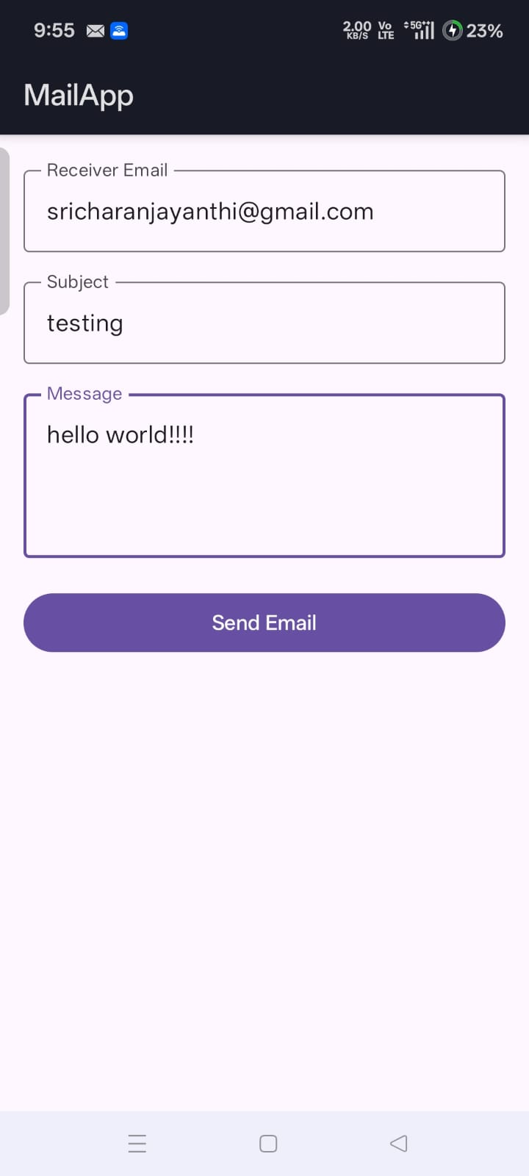
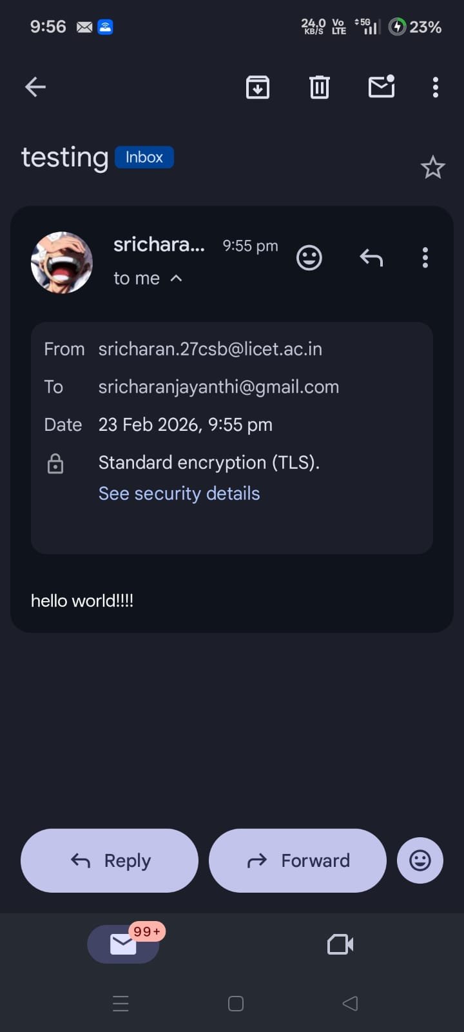

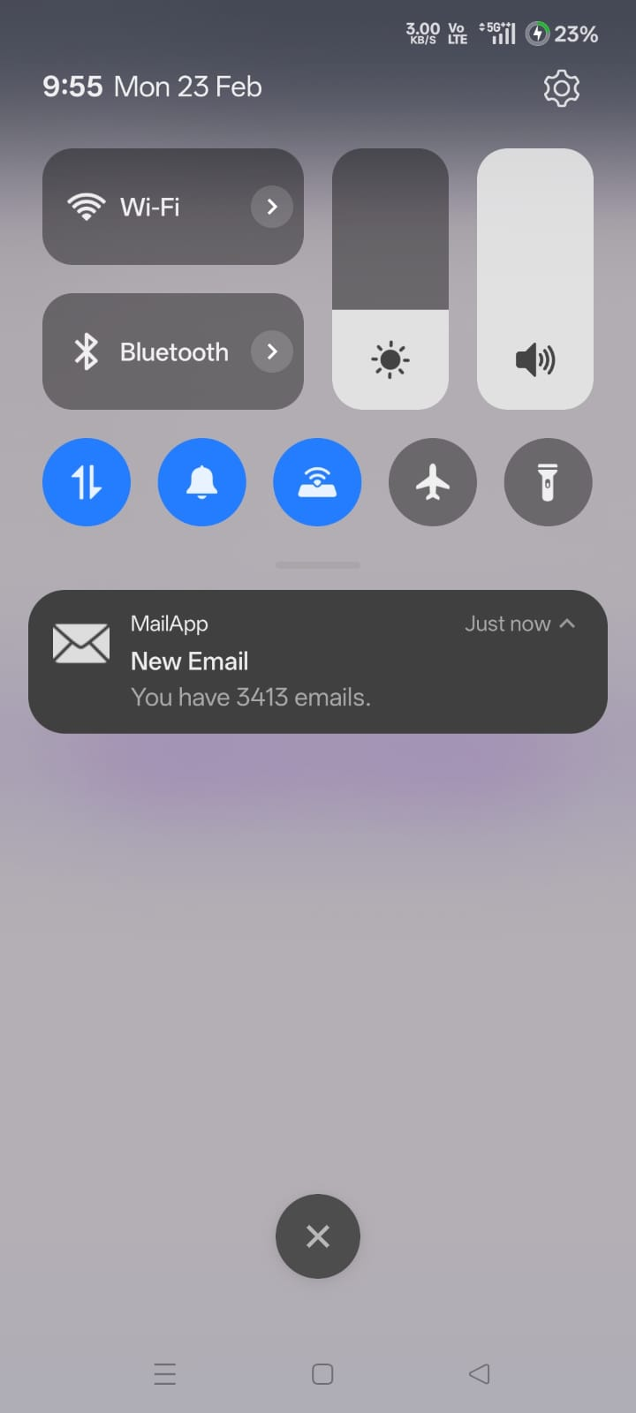

Result

Thus, an Android application was successfully developed to send emails and generate notifications upon receiving mails or messages using Android components such as UI elements, SMTP protocol, background processing, and notification services.

EX: 4

DATE:

Aim
To develop an Android application using Java and Database to manage a simple library system which allows:
- Displaying available books
- Lending books
- Reserving books
while assuming that student information is stored in a database server.

Procedure
- Create a new Android project in Android Studio.
- Design the user interface using XML (buttons and text display).
- Create a SQLite database to store book details.
- Insert sample book records into the database.
- Write Java code to:
  - Display available books
  - Lend a book
  - Reserve a book
- Connect the UI with database operations.
- Run the application on an emulator or mobile device.

PROGRAM

1. activity_main.xml
<?xml version="1.0" encoding="utf-8"?>
<LinearLayout
xmlns:android="http://schemas.android.com/apk/res/android"
android:layout_width="match_parent"
android:layout_height="match_parent"
android:orientation="vertical"
android:padding="20dp">

<Button
android:id="@+id/btnAvailable"
android:layout_width="match_parent"
android:layout_height="wrap_content"
android:text="Show Available Books"/>

<Button
android:id="@+id/btnLend"
android:layout_width="match_parent"
android:layout_height="wrap_content"
android:text="Lend Book"/>

<Button
android:id="@+id/btnReserve"
android:layout_width="match_parent"
android:layout_height="wrap_content"
android:text="Reserve Book"/>

<TextView
android:id="@+id/txtResult"
android:layout_width="match_parent"
android:layout_height="wrap_content"
android:textSize="16sp"
android:padding="10dp"/>
</LinearLayout>

2. DatabaseHelper.java

package com.example.libraryapp;

import android.content.Context;
import android.database.sqlite.SQLiteDatabase;
import android.database.sqlite.SQLiteOpenHelper;

public class DatabaseHelper extends SQLiteOpenHelper {

public static final String DB_NAME = "LibraryDB.db";

public DatabaseHelper(Context context) {
super(context, DB_NAME, null, 1);
}

@Override
public void onCreate(SQLiteDatabase db) {
db.execSQL("CREATE TABLE books(id INTEGER PRIMARY KEY, name TEXT, status TEXT)");

db.execSQL("INSERT INTO books VALUES(1,'Java PROGRAMming','Available')");
db.execSQL("INSERT INTO books VALUES(2,'Android Development','Available')");
db.execSQL("INSERT INTO books VALUES(3,'Data Structures','Available')");
}

@Override
public void onUpgrade(SQLiteDatabase db, int oldVersion, int newVersion) {
db.execSQL("DROP TABLE IF EXISTS books");
onCreate(db);
}
}

3. MainActivity.java

package com.example.libraryapp;

import androidx.appcompat.app.AppCompatActivity;
import android.database.Cursor;
import android.database.sqlite.SQLiteDatabase;
import android.os.Bundle;
import android.view.View;
import android.widget.Button;
import android.widget.TextView;

public class MainActivity extends AppCompatActivity {

Button btnAvailable, btnLend, btnReserve;
TextView txtResult;
DatabaseHelper dbHelper;
SQLiteDatabase db;

@Override
protected void onCreate(Bundle savedInstanceState) {
super.onCreate(savedInstanceState);
setContentView(R.layout.activity_main);

btnAvailable = findViewById(R.id.btnAvailable);
btnLend = findViewById(R.id.btnLend);
btnReserve = findViewById(R.id.btnReserve);
txtResult = findViewById(R.id.txtResult);

dbHelper = new DatabaseHelper(this);
db = dbHelper.getWritableDatabase();

btnAvailable.setOnClickListener(v -> showAvailableBooks());

btnLend.setOnClickListener(v -> {
db.execSQL("UPDATE books SET status='Lent' WHERE id=1");
txtResult.setText("Book ID 1 has been Lent");
});

btnReserve.setOnClickListener(v -> {
db.execSQL("UPDATE books SET status='Reserved' WHERE id=2");
txtResult.setText("Book ID 2 has been Reserved");
});
}

private void showAvailableBooks() {
Cursor c = db.rawQuery("SELECT * FROM books WHERE status='Available'", null);
StringBuilder buffer = new StringBuilder();

while (c.moveToNext()) {
buffer.append("ID: ").append(c.getInt(0))
.append(" Name: ").append(c.getString(1))
.append("\n");
}

txtResult.setText(buffer.toString());
}
}

Output

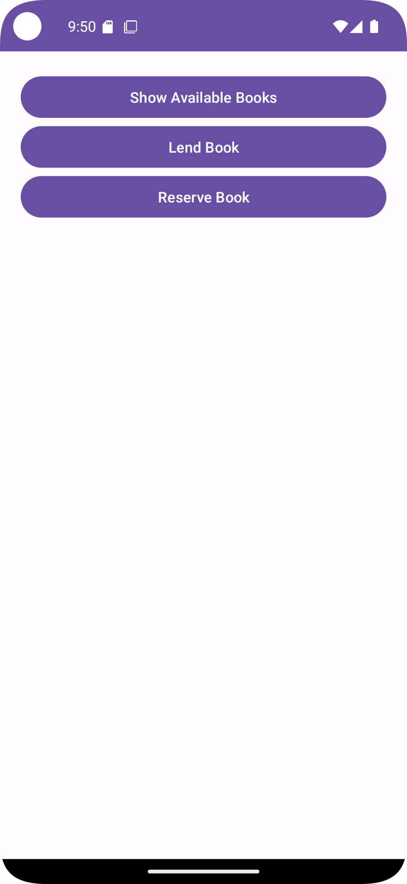
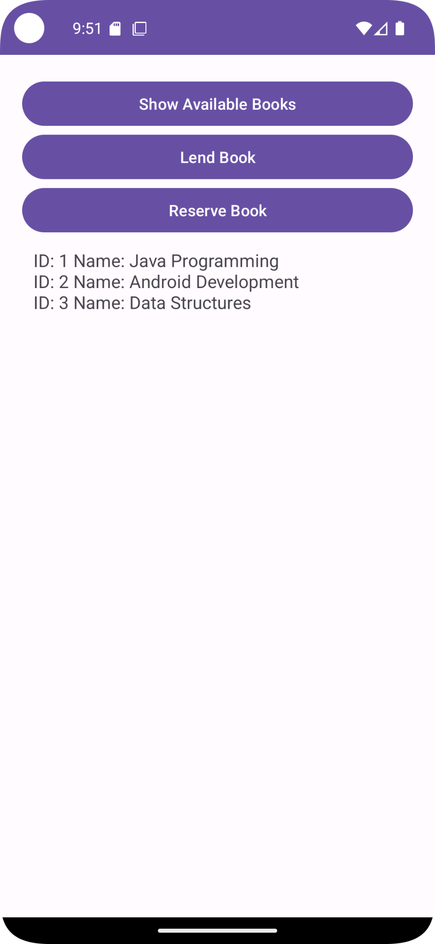

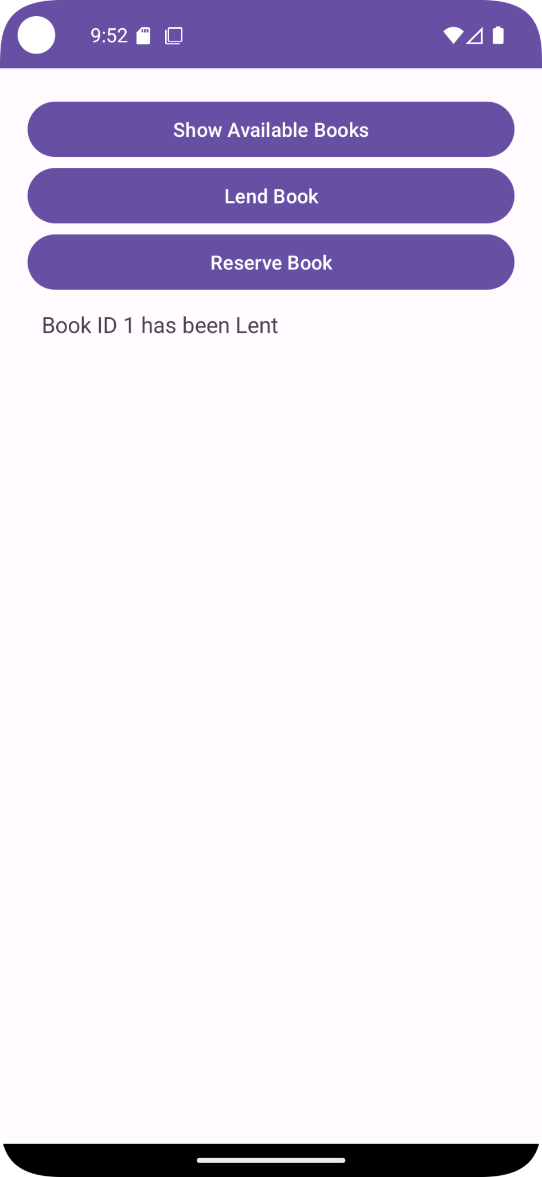

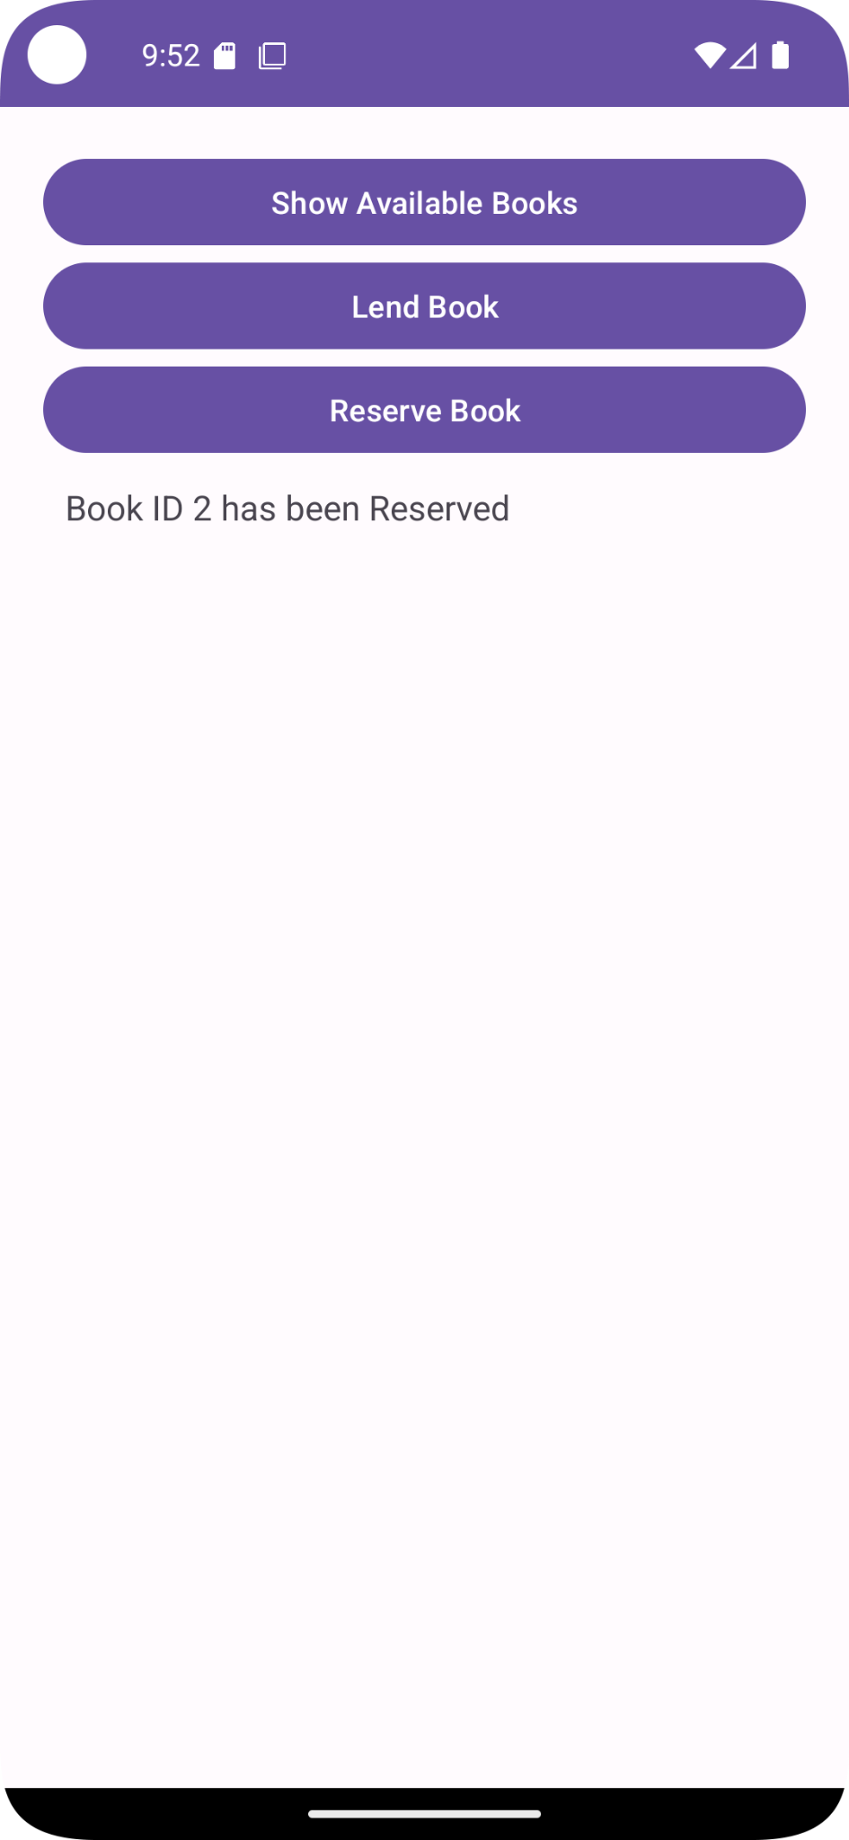

Result
Thus, an Android application using Java and Database for a simple Library System was successfully developed to display available books, lend books, and reserve books using SQLite database while assuming student information is stored on a database server.

Ex.No: 6
Date:

Aim: Design and develop an android application using Apache Cordova to find and display the current location of the user.

Procedure:

- Install Apache Cordova using npm.
- Create a new Cordova project using:
- Navigate to the project folder using:
- Add Android platform using:
cordova platform add android
- Install Geolocation plugin using:
cordova plugin add cordova-plugin-geolocation
- Open index.html and design the layout with:
One Button
One output element (Text/Div)
- Write JavaScript code to:
Get current location using navigator.geolocation.getCurrentPosition()
Display latitude and longitude in the output element
- Build the application using:
- Run the application on emulator or device using:
Program:
Index.html
<!DOCTYPE html>
<html>
<head>
<title>Location Finder</title>
<style>
body {
font-family: Arial;
text-align: center;
margin-top: 50px;
}
button {
padding: 10px 20px;
font-size: 16px;
}
#output {
margin-top: 20px;
font-size: 18px;
}
</style>
</head>
<body>

<h1>Find My Location</h1>
<button onclick="getLocation()">Get Location</button>

<div id="output"></div>
<script src="cordova.js"></script>

<script>
document.addEventListener("deviceready", function () {
console.log("Device ready");
});

function getLocation() {
var output = document.getElementById("output");

output.innerHTML = "Fetching location...";

if (!navigator.geolocation) {
output.innerHTML = "Geolocation not supported";
return;
}

navigator.geolocation.getCurrentPosition(
function(position) {
output.innerHTML =
"Latitude: " + position.coords.latitude +
"<br>Longitude: " + position.coords.longitude;
},
function(error) {
output.innerHTML =
"ERROR CODE: " + error.code + "<br>" +
"MESSAGE: " + error.message;
},
{
enableHighAccuracy: true,
timeout: 10000,
maximumAge: 0
}
);
}
</script>

</body>
</html>

Output:
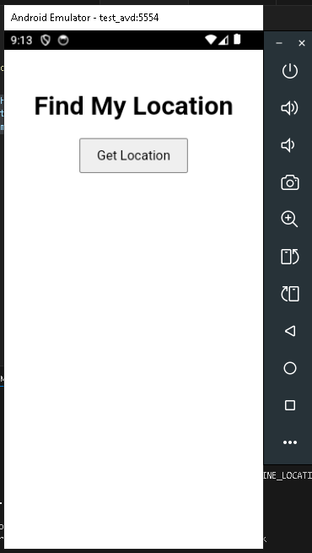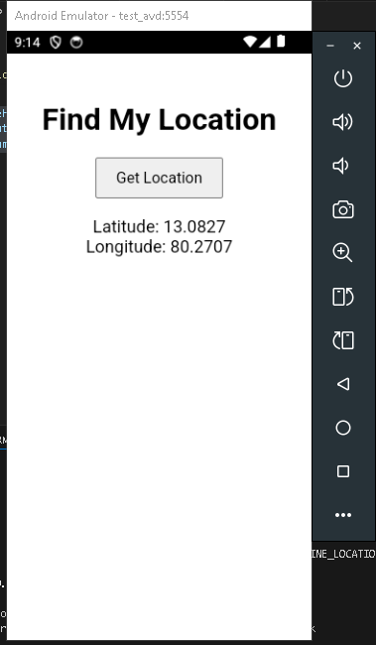

Result: Hence, an android application using Apache Cordova to find and display the current location of the user.was developed and output was obtained.

Ex.No.: 7
DATE: RECIPE APP USING IONIC FRAMEWORK

AIM:
To design and develop a mobile application using Ionic Framework that suggests recipes based on the ingredients available with the user and provides nutrition information and cooking instructions.

PROCEDURE:
- Install Ionic CLI globally: npm install -g @ionic/cli
- Create a new Ionic project using React: ionic start recipe-app-react blank --type react
- Navigate to the project directory: cd recipe-app-react
- Design the UI and implement logic in src/pages/Home.tsx:
  - Input field for ingredients, using React state (useState).
  - Button to trigger the search recipes function.
  - Section to map and display matched recipes, nutrition, and instructions dynamically.
- Style the UI using src/pages/Home.css with a warm color theme.
- Run the application: ionic serve
- Build and run on Android:
  - ionic build
  - npx cap add android
  - npx cap open android

CODE:

src/pages/Home.tsx

import {
IonContent,
IonHeader,
IonPage,
IonTitle,
IonToolbar,
IonItem,
IonInput,
IonButton,
IonList,
IonLabel,
} from '@ionic/react';
import { useState } from 'react';
import './Home.css';

const Home: React.FC = () => {
const [ingredients, setIngredients] = useState<string>('');
const [recipes, setRecipes] = useState<any[]>([]);

const findRecipes = () => {
const input = ingredients.toLowerCase();

// Sample static data
const allRecipes = [
{
name: 'Tomato Soup',
ingredients: ['tomato'],
nutrition: 'Calories: 80 kcal',
instructions: 'Boil tomatoes, blend, and cook with spices.'
},
{
name: 'Onion Omelette',
ingredients: ['onion', 'egg'],
nutrition: 'Calories: 150 kcal',
instructions: 'Beat eggs, add onions, cook on pan.'
}
];

const matchedRecipes = allRecipes.filter(r =>
r.ingredients.some(i => input.includes(i))
);

setRecipes(matchedRecipes);
};

return (
<IonPage>
<IonHeader>
<IonToolbar color="tertiary">
<IonTitle>Recipe Finder</IonTitle>
</IonToolbar>
</IonHeader>

<IonContent className="ion-padding custom-background">
<IonItem className="custom-input-item" lines="none">
<IonInput
className="custom-input"
value={ingredients}
placeholder="Enter ingredients (e.g., tomato, onion)"
onIonInput={(e) => setIngredients(e.detail.value! as string)}
clearInput
></IonInput>
</IonItem>

<IonButton expand="block" color="warning" onClick={findRecipes} className="find-btn">
Find Recipes
</IonButton>

{recipes.length > 0 && (
<IonList className="custom-list" lines="none">
{recipes.map((recipe, index) => (
<IonItem key={index} className="recipe-item">
<IonLabel className="ion-text-wrap">
<h2 className="recipe-title">{recipe.name}</h2>
<p><b>Nutrition:</b> {recipe.nutrition}</p>
<p><b>Instructions:</b> {recipe.instructions}</p>
</IonLabel>
</IonItem>
))}
</IonList>
)}
</IonContent>
</IonPage>
);
};
export default Home;

src/pages/Home.css
ion-title {
text-align: center;
font-weight: bold;
}

.custom-background {
--background: #fdf5e6;
}

.custom-input-item {
margin-top: 10px;
--background: #ffffff;
--color: black;
border-radius: 8px;
box-shadow: 0 2px 4px rgba(0,0,0,0.1);
border: 1px solid #ffe4b5;
}

.custom-input {
--color: black;
color: black;
}

.find-btn {
margin-top: 20px;
margin-bottom: 20px;
--border-radius: 8px;
--box-shadow: 0 4px 6px rgba(0,0,0,0.1);
}

.custom-list {
background: transparent;
}

.recipe-item {
margin-top: 15px;
--background: #ffffff;
border-radius: 12px;
box-shadow: 0 4px 8px rgba(0,0,0,0.1);
border-left: 5px solid #ff8c00;
}

.recipe-title {
color: #d2691e;
font-size: 1.3rem;
font-weight: bold;
margin-bottom: 8px;
}

ion-label p {
color: #555;
font-size: 0.95rem;
line-height: 1.4;
margin-bottom: 4px;
}

ion-label b {
color: #333;
}

OUTPUT:
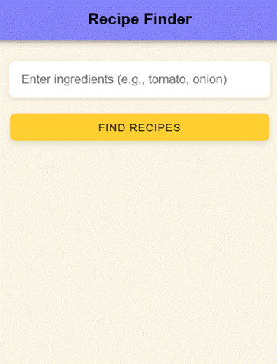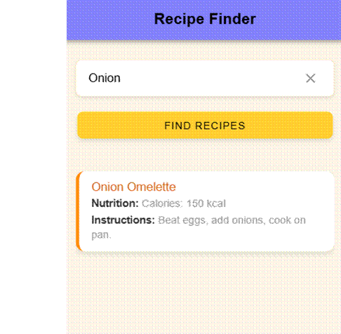

RESULT:
The Ionic-based recipe suggestion application was successfully developed and executed using React.
Ex.No.: 7
DATE: RECIPE APP USING IONIC FRAMEWORK

AIM:
To design and develop a mobile application using Ionic Framework that suggests recipes based on the ingredients available with the user and provides nutrition information and cooking instructions.

PROCEDURE:
- Install Ionic CLI globally: npm install -g @ionic/cli
- Create a new Ionic project using React: ionic start recipe-app-react blank --type react
- Navigate to the project directory: cd recipe-app-react
- Design the UI and implement logic in src/pages/Home.tsx:
  - Input field for ingredients, using React state (useState).
  - Button to trigger the search recipes function.
  - Section to map and display matched recipes, nutrition, and instructions dynamically.
- Style the UI using src/pages/Home.css with a warm color theme.
- Run the application: ionic serve
- Build and run on Android:
  - ionic build
  - npx cap add android
  - npx cap open android

CODE:

src/pages/Home.tsx

import {
IonContent,
IonHeader,
IonPage,
IonTitle,
IonToolbar,
IonItem,
IonInput,
IonButton,
IonList,
IonLabel,
} from '@ionic/react';
import { useState } from 'react';
import './Home.css';

const Home: React.FC = () => {
const [ingredients, setIngredients] = useState<string>('');
const [recipes, setRecipes] = useState<any[]>([]);

const findRecipes = () => {
const input = ingredients.toLowerCase();

// Sample static data
const allRecipes = [
{
name: 'Tomato Soup',
ingredients: ['tomato'],
nutrition: 'Calories: 80 kcal',
instructions: 'Boil tomatoes, blend, and cook with spices.'
},
{
name: 'Onion Omelette',
ingredients: ['onion', 'egg'],
nutrition: 'Calories: 150 kcal',
instructions: 'Beat eggs, add onions, cook on pan.'
}
];

const matchedRecipes = allRecipes.filter(r =>
r.ingredients.some(i => input.includes(i))
);

setRecipes(matchedRecipes);
};

return (
<IonPage>
<IonHeader>
<IonToolbar color="tertiary">
<IonTitle>Recipe Finder</IonTitle>
</IonToolbar>
</IonHeader>

<IonContent className="ion-padding custom-background">
<IonItem className="custom-input-item" lines="none">
<IonInput
className="custom-input"
value={ingredients}
placeholder="Enter ingredients (e.g., tomato, onion)"
onIonInput={(e) => setIngredients(e.detail.value! as string)}
clearInput
></IonInput>
</IonItem>

<IonButton expand="block" color="warning" onClick={findRecipes} className="find-btn">
Find Recipes
</IonButton>

{recipes.length > 0 && (
<IonList className="custom-list" lines="none">
{recipes.map((recipe, index) => (
<IonItem key={index} className="recipe-item">
<IonLabel className="ion-text-wrap">
<h2 className="recipe-title">{recipe.name}</h2>
<p><b>Nutrition:</b> {recipe.nutrition}</p>
<p><b>Instructions:</b> {recipe.instructions}</p>
</IonLabel>
</IonItem>
))}
</IonList>
)}
</IonContent>
</IonPage>
);
};
export default Home;

src/pages/Home.css
ion-title {
text-align: center;
font-weight: bold;
}

.custom-background {
--background: #fdf5e6;
}

.custom-input-item {
margin-top: 10px;
--background: #ffffff;
--color: black;
border-radius: 8px;
box-shadow: 0 2px 4px rgba(0,0,0,0.1);
border: 1px solid #ffe4b5;
}

.custom-input {
--color: black;
color: black;
}

.find-btn {
margin-top: 20px;
margin-bottom: 20px;
--border-radius: 8px;
--box-shadow: 0 4px 6px rgba(0,0,0,0.1);
}

.custom-list {
background: transparent;
}

.recipe-item {
margin-top: 15px;
--background: #ffffff;
border-radius: 12px;
box-shadow: 0 4px 8px rgba(0,0,0,0.1);
border-left: 5px solid #ff8c00;
}

.recipe-title {
color: #d2691e;
font-size: 1.3rem;
font-weight: bold;
margin-bottom: 8px;
}

ion-label p {
color: #555;
font-size: 0.95rem;
line-height: 1.4;
margin-bottom: 4px;
}

ion-label b {
color: #333;
}

OUTPUT:
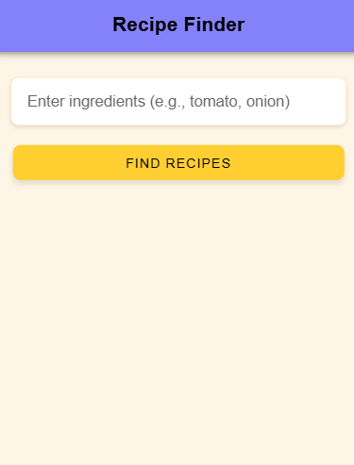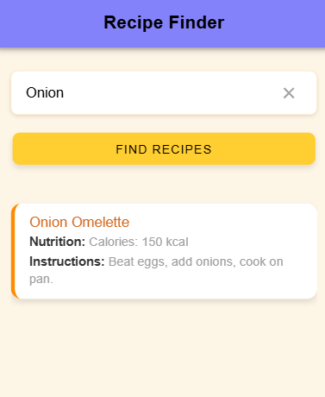

RESULT:
The Ionic-based recipe suggestion application was successfully developed and executed using React.
EX: 08 BUILD A CROSS PLATFORM APPLICATION FOR A BMI CALCULATOR USING
DATE: REACT NATIVE

AIM:
To design and develop a cross-platform mobile application using React Native that calculates a user’s Body Mass Index (BMI) based on height and weight inputs, and displays the BMI value along with the corresponding health category.

PROCEDURE:
- Install Node.js (if not installed already).
- Install Expo CLI globally:
npm install -g expo-cli
- Create a new React Native Expo project:
npx create-expo-app bmi-calculator
- Navigate into the project folder:
cd bmi-calculator
- Open the project in a code editor (e.g., VS Code).
- Modify the screen file located at:
app/(tabs)/index.tsx
to include:
  - Input fields for height and weight
  - A Calculate button
  - Logic to compute BMI using React state (useState)
  - A display section showing BMI result and category
- Add additional UI styling inside the same file using React Native StyleSheet.
- Run the application in development mode:
npx expo start
Open on:
  - Android (Expo Go App)
  - iOS (Expo Go App)
  - Web (press w)
- Ensure the UI updates correctly and BMI is shown on screen.

CODE:

app/(tabs)/index.tsx
import React, { useState } from "react";
import {
StyleSheet,
TextInput,
View,
TouchableOpacity,
SafeAreaView,
ScrollView,
} from "react-native";
import { ThemedText } from "@/components/themed-text";
import { ThemedView } from "@/components/themed-view";

export default function HomeScreen() {
const [height, setHeight] = useState("");
const [weight, setWeight] = useState("");
const [bmi, setBmi] = useState<number | null>(null);
const [category, setCategory] = useState("");

const calculateBMI = () => {
if (!height || !weight) return;

const h = parseFloat(height) / 100;
const w = parseFloat(weight);

if (isNaN(h) || isNaN(w) || h <= 0) return;

const bmiValue = w / (h * h);
const rounded = Number(bmiValue.toFixed(1));

setBmi(rounded);

if (rounded < 18.5) setCategory("Underweight");
else if (rounded < 24.9) setCategory("Normal weight");
else if (rounded < 29.9) setCategory("Overweight");
else setCategory("Obesity");
};

return (
<SafeAreaView style={{ flex: 1 }}>
<ScrollView contentContainerStyle={styles.container}>
<ThemedText type="title" style={styles.title}>
BMI Calculator
</ThemedText>

<TextInput
placeholder="Height (cm)"
keyboardType="numeric"
value={height}
onChangeText={setHeight}
style={styles.input}
/>

<TextInput
placeholder="Weight (kg)"
keyboardType="numeric"
value={weight}
onChangeText={setWeight}
style={styles.input}
/>

<TouchableOpacity style={styles.button} onPress={calculateBMI}>
<ThemedText style={styles.buttonText}>Calculate</ThemedText>
</TouchableOpacity>

{bmi !== null && (
<ThemedView style={styles.resultContainer}>
<ThemedText type="title" style={styles.resultText}>
BMI: {bmi}
</ThemedText>
<ThemedText style={styles.categoryText}>{category}</ThemedText>
</ThemedView>
)}
</ScrollView>
</SafeAreaView>
);
}

const styles = StyleSheet.create({
container: {
padding: 20,
alignItems: "center",
},
title: {
marginBottom: 20,
},
input: {
width: "100%",
backgroundColor: "#ffffff",
padding: 15,
borderRadius: 10,
marginVertical: 10,
fontSize: 18,
borderWidth: 1,
borderColor: "#ccc",
},
button: {
backgroundColor: "#007bff",
padding: 15,
borderRadius: 10,
width: "100%",
alignItems: "center",
marginTop: 10,
},
buttonText: {
color: "white",
fontWeight: "bold",
},
resultContainer: {
marginTop: 30,
alignItems: "center",
},
resultText: {
fontSize: 28,
marginBottom: 10,
},
categoryText: {
fontSize: 20,
},
});

OUTPUT:
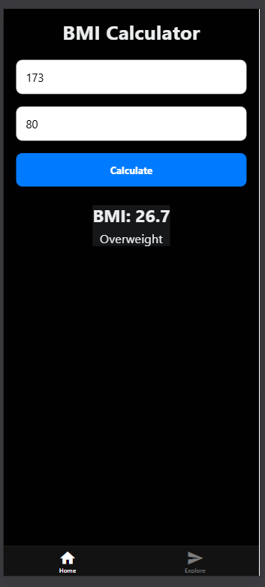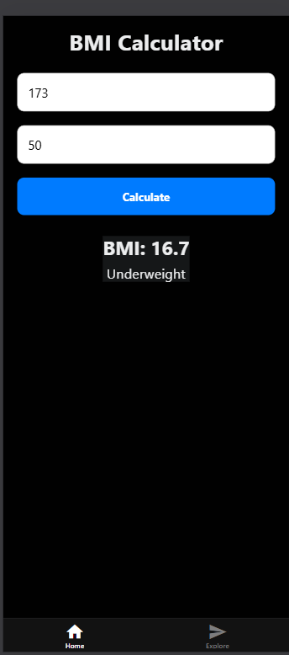

RESULT:
The cross-platform BMI Calculator mobile application was successfully designed, developed, and executed using React Native with Expo. The app accurately calculates BMI based on user input and displays both the BMI value and corresponding health category.

